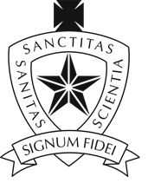
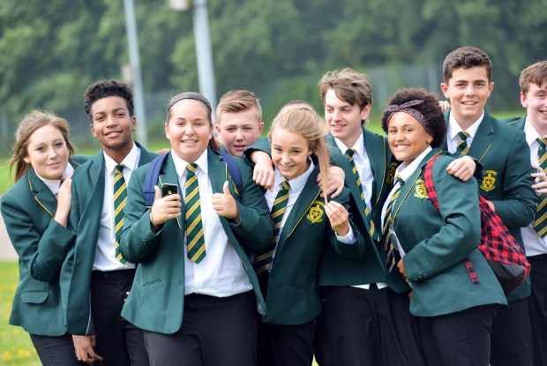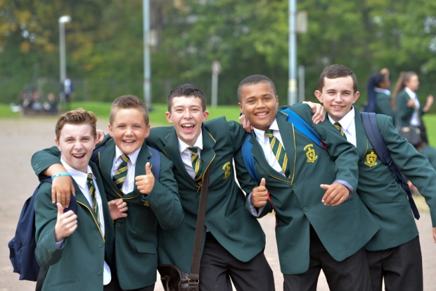

‘Period 6’ is an extension to our school day and it is an opportunity for pupils, parents and staff to engage in a variety of courses to develop their knowledge, learning and life skills.

Period 6 - September 2015
Staff | Course | Day | Time
Level 2/3 courses
Mr Harper | Geology GCSE | Monday | 2hrs
Mr Fleet | Psychology GCSE | Thursday | 2hrs
Mrs D.James | Sociology GCSE | Thursday | 2hrs
Mr Miles/Miss Pearson | Philosophy AS Level | Monday | 2hrs
Mrs Hobbs/Miss Evans | Geography GCSE | Monday | 2hrs
Mrs N.James/Miss Vella | Photography GCSE | Thursday | 2hrs
Mrs Hill | Welsh GCSE Top Up | Thursday | 2hrs
Mrs N.James | Jamie Oliver BTEC | Thursday | 2hrs
Enrichment courses
Mr Nelson/ Mr Walsh | Fishing/Angling | N/A | Variable
Mr Miles | Debating society | Thursday | 1hr
Mr Richards/Mr Harper | Duke of Edinburgh | N/A | Variable
Miss Chick | Make Up & Manicures | TBC | 1hr
Mrs Lewis/Dr Rice | Science 'Crest Award' | Monday | 2hrs
Miss Williams/Mr Healey | Life Skills | Thursday | 2hrs
Mrs Hill | Welsh for adults/beginners | Monday | 2 hrs
Miss Bendle/Mrs Jenkins | Holiday Spanish | Monday | 1 hr

There will be an opportunity to discuss the courses with the providers at the Period 6 Information Evening on Tuesday 7th of July from 5:00 – 6:00pm in the Main Hall.
If you have any problems/queries please contact Mrs Fry (rf@stilltyds.org.uk) or myself (pm@stilltyds.org.uk).
Mr P Moriarty
Deputy Headteacher
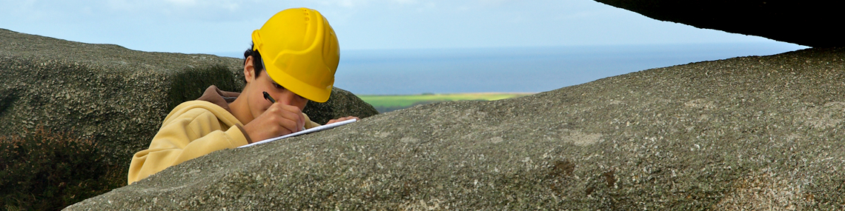
GCSE GEOLOGY
Geology
What is Geology?
Geology is an applied branch of science that uses mathematical, physical, chemical and biological principles to explain the structure, evolution and dynamics of the Earth. Like all sciences, Geology draws extensively on the skills of observation, imagination and the synthesis of collected information and ideas.
The course covers a wide variety of topics starting with learning to identify and interpret the materials that the Earth is made of: minerals, rocks and fossils. These give us clues about the history of the Earth so that we can learn how to piece together the story of the Earth. We also learn how to interpret the landscape around us. The subject is very practically-based and is taught to get the pupils “hands-on” the materials we study. The course also covers how the Earth works including plate tectonics and the volcanic eruptions and earthquakes it causes. Geologists play an important part in reducing the effects of these hazards. We learn how to read the clues to tell us how the landscape forms. We learn about the history of the Earth; how animals, like the dinosaurs, lived and became extinct; how Britain was in the past, why it is like it is today and how it will change in the future. The course finishes by looking at what professional geologists do such as finding and extracting the raw materials we need from the Earth.
Why Study Geology?
Being an applied science, Geology has many applications to human activities. Our modern society cannot exist without the resources explored for, and exploited by, geologists; notable examples being oil, gas, coal, water, building materials and metals. Geologists are also involved in hazard prediction, i.e., earthquake, volcano and landslide forecasting. In major civil engineering projects, geologists are required to investigate the strength and nature of the ground, and a major recent growth area for geologists is in environmental projects.

GCSE Geology
An interest in science and physical geography are the entry requirements. Fieldwork is an integral part of Geology and a number of fieldtrips that will take place throughout the two year course.
GCSE Scheme of Assessment | Time | Percentage Weighting
On Screen Examination Paper | 1 .5 Hours | 75%
Controlled Internal Assessment | 1 Hour | 25%

GEOLOGY
GCSE Psychology
Psychology
What is Psychology?
Psychology is the scientific study of how people behave, think and feel. Psychologists study everything about the human experience from the basic workings of the human brain to consciousness, memory, reasoning and language, to personality and mental health.
Psychology is one of the most popular university courses. Psychology is also one of the fastest growing professions.

GCSE Psychology
Candidates will cover core areas of Psychology through two units:

Unit 1:
Social, Biological and Developmental Psychology.

Unit 2:
Cognitive Psychology; Individual Differences; and Ethics and Research
Issues in Psychology

Sociology
What is Sociology?
Sociology will offer pupils the chance to study the world we live in and the various human forms of society. We will examine our culture, social organisations and individual lives. We look at the consequences of issues such as romantic love, racism, prejudice, deviant behaviour and ageing. Sociology will examine and try to explain these issues through developing new skills, such as researching, compiling data through questionnaire's and presenting findings. Sociology students are excellent at evaluating and clearly communicating with others. Sociology GCSE is useful for students who wish to join the police force, social work, teaching and management roles.
GCSE Sociology
UNIT1: Understanding Social Processes (50%)
Written Paper: 1 ½ hours
One multi part compulsory question based on stimulus materials and assessing themes of
socialisation, inequality and research methods. (30%)
Options
One three part extended writing question must be answered from one of the
following: Family; Education; Mass Media; Sport. (20%)

UNIT 2: Understanding Social Structures (50%)
Written Paper: 1 ½ hours
One multi-part compulsory question based on stimulus materials and assessing themes of
inequality, power, socialisation and research methods. (30%)
Options
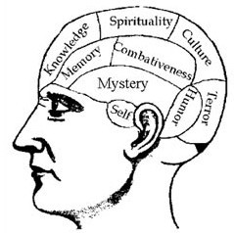
One three part extended writing question must be answered from one of the following:
Work; Power and Participation; Crime and Deviance; Global Citizenship. (20%)

Philosophy & Ethics

Philosophy & Ethics
What is Philosophy & Ethics?
The study of religion, in particular philosophy and ethics is well known for developing reasoning and communication skills that are central to success in all professions and all areas of study, such as the ability to express and defend coherent views on complex issues.
Learners also acquire knowledge of logic, epistemology, metaphysics and other areas which provide excellent background for careers in medicine, law, government service, ministry, education and many other fields. The study of religion provides that breadth, with insights into psychology, anthropology, history, sociology and theology.
AS Philosophy & Ethics
Course Content
Candidates will study two modules at ‘AS’ Level:
RS1/2 PHIL: ‘Philosophy of Religion’ – This includes a study of the proofs for the existence of God: the Teleological and Cosmological Arguments; the Problem of Evil; and Mysticism.
RS1/2 ETH: ‘Religion and Ethics’ – This includes a study of Ethical Theories including Situation Ethics; Natural Law Theory; Utilitarianism; and Applied Ethics.
Assessment Procedure
2x 75 minute written papers in the summer of ‘AS’ - 1 x Philosophy, 1 x ethics

Geography

Geography
What is Geography?
Pupils continue to develop their skills on Locating, communication, investigation and understanding processes. Each of these 4 elements will aid pupils in completing the 2 external examinations, a decision making coursework and fieldwork. Pupils will be examined at either Foundation or Higher level.
GCSE Geography
How will I be assessed?

This course is made up assessments carried out in the form of an exam and coursework.

Unit 1: Core Geography (40%). Written Paper: 1 hour 45 minutes (F/H). 90 marks (80 UMS). Six short compulsory structured data response questions, one question from each of the core themes. These questions will each have an element of extended prose.

Unit 2: Options Geography (35%). Written Paper: 1 hour 15 minutes (F/H)
72 marks (70 UMS). Three in depth structured data response questions with extended writing – one physical, one human and one other selected from the three physical and three human optional themes.

Unit 3: Geographical Enquiry: (25%).Controlled Assessment 100 marks (50 UMS). An enquiry based on fieldwork (10%) and a problem solving decision-making
exercise (15%).

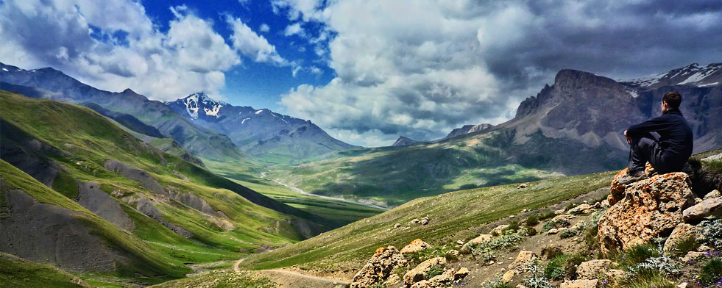
.

Photography

Photography
What is Photography?
Learning to see, think and communicate in new ways? Then come and join photography.

Pupils will be introduced to a variety of experiences that explore a range of photographic media, techniques and processes. They should be made aware of both traditional and new technologies. Pupils will produce two units of coursework (60%) and one exam unit (40%). Pupils will work in sketchbooks/workbooks/journals to underpin their work where appropriate. They may wish to develop their drawing skills in order to produce storyboards, thumbnail sketches and/or diagrams, where appropriate. Pupils may use traditional methods and/or digital techniques to produce images.
GCSE Photography
Pupils are required to work in one or more area(s) of Photography, such as those listed below depending on the project brief. They may explore overlapping areas and combinations of areas:
- portraiture
- landscape photography (working from the urban, rural and/or coastal environment)
- still life photography (working from objects or from the natural world)
- documentary photography, photojournalism
- fashion photography
- experimental imagery
- multimedia
- photographic installation
- moving image (video, film, animation).
Pupils must have their own camera or mobile phone to take photos.

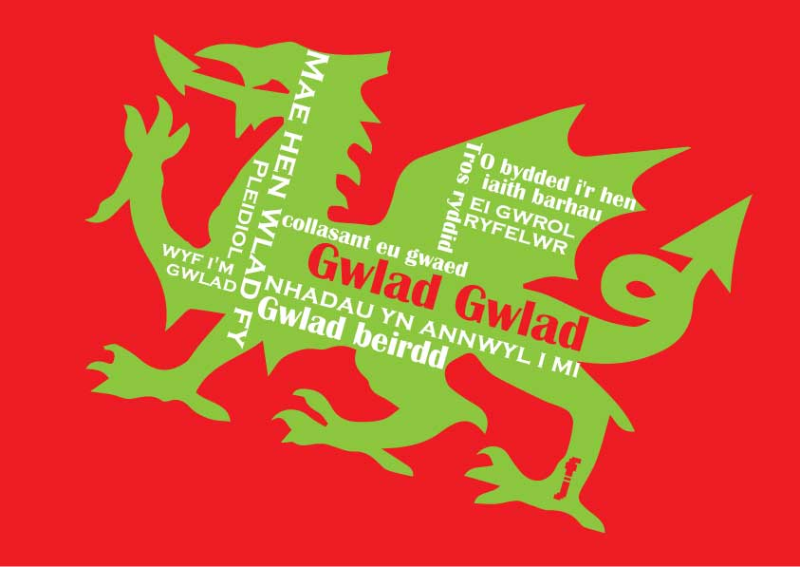

Welsh Full Course

Welsh Full Course

Welsh
What is Welsh Full Course GCSE Top Up?
The Welsh top up class, leading to a full GCSE qualification, will provide learning experiences which give all candidates the opportunity to reach their full potential in Welsh, with many more opportunities to develop a real grasp of the language as opposed to simply knowing how to pass the exam. The top up class will also provide far greater opportunities to develop the important oracy aspect of the syllabus. The full course qualification is essential if students have any interest in pursuing Welsh beyond Year 11 and is a highly desirable qualification in many areas of work. The syllabus aims to develop students’ essential skills while undertaking practical tasks which fulfil the needs of candidates, employers and further education.

In addition to the short course units followed during regular timetabled ‘core’ Welsh lessons - unit 1 (external reading and writing examination) and Unit 2 (controlled assessments) - students following the full course syllabus during period 6 will have to complete units 3 and 4.

Unit 3 – Controlled assessment (30%)
Consisting of two (un-tiered) tasks;
Task 1 – Reading (10%) and Writing (5%)
Task 2 – Speaking (5%) and Writing (10%)

Unit 4 – Oral examination (20%) Duration 10 minutes
Pair/Group oral examination (with class teacher)
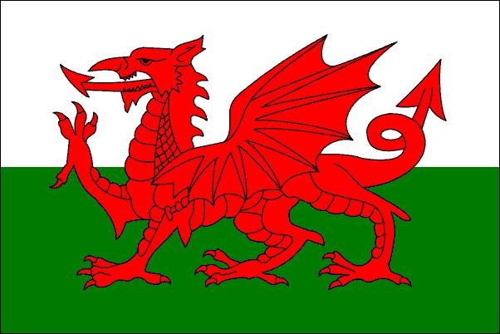

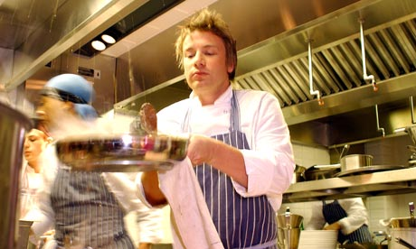
Jamie’s Home Cooking Skills

Jamie’s Home Cooking Skills
What is Jamie’s Home Cooking Skills?
We’re really excited about the new Jamie’s Home Cooking Skills qualification and are delighted to be able to offer the opportunity to follow this course at St Illtyd’s.
BTEC Jamie’s Home Cooking Skills will teach you to cook great food that tastes amazing, saves money and, in the long run, will help you lead a happier, healthier life. This is a hands-on course that helps pupilsdevelop the essential skills they need to cook simple, nutritious, affordable food. This is about real food, for real life.
Cooking is, without a doubt, one of the most important skills a person can ever learn and share. Once someone has that knowledge, that's it - they're set for life.
Home Cooking Skills is so much more than a qualification: it's a critical life skill and provides students with sensible, practical knowledge that they can take into the world and actually use. Whether they're having a party, cooking for mates, feeding their future children or making lunch, they'll be fending for themselves, saving money and using these skills every day for the rest of their lives. The course is supported by user-friendly work sheets, web links, videos and images so learning can be developed in your own time at home too. Teaching will be supportive, relaxed and collaborative, so we can all learn and enjoy the experience of cooking great food together.
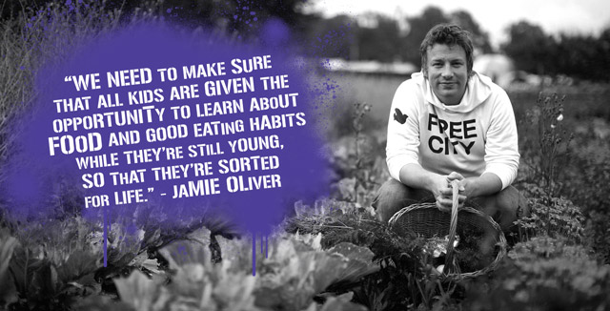
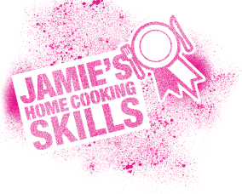
Angling

Introduction to angling and the environment
What is Angling?
Angling is a totally inclusive sport that offers no barriers to those wishing to participate and offers an immediate reward to those who go fishing. It is a fun and healthy sport enjoyed by millions of people throughout the UK every year. Anglers not only go fishing to catch fish but also because they enjoy and appreciate the environment in which angling takes place.
Pupils will learn about the following subjects:
Geography - Water Cycle Weather Patterns, Wind Direction; Air Pressure.
Biology - Common Plants and Animals Found Close to the Water Side; Fish Anatomy; Photosynthesis; Food Chain; Pond Life; Fish Identification; Feeding Habits and Fish Handling.
Numeracy - Measuring Water Depth; Using Weights to Balance Floats; Line Strength and Test Curves of Rods.
Literacy - Course Work and Compilation of Evidence Portfolio; Word Search and Written Assessment Paper.
Waterside Safety; The Countryside Code; Assembling and Using a Range of Angling Equipment; Bait Identification and Selection.
All these skills enable young people to have an in-depth understanding of their environment and learn how to fish safely and correctly.
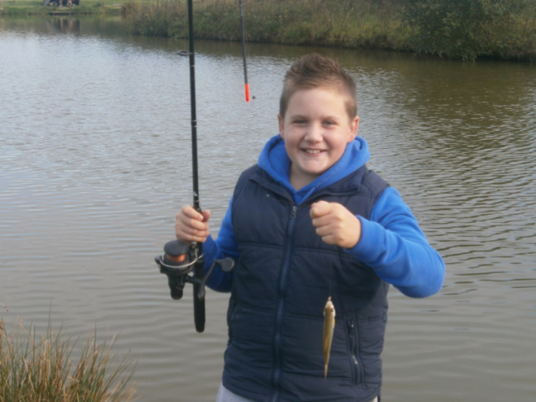

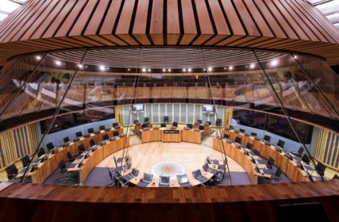
Debating Society

Debating Society
What is Debating Society?
Your knowledge, your opinion and your understanding are only as valid as your ability to express them. Debating and public speaking offers you the skills to reason and argue responsibly, listening and responding to others' views where appropriate.
There are a range of local and national competitions for speech making, debating and discussion which we will enter. You will develop the ability to speak confidently, listen attentively and think quickly in order to put forward your ideas and opinions as best you can.
There are real issues in the world. There are real issues in your life. These issues need to be addressed and a solution needs to be found. Effective discussion and debating are the only ways in which groups of people can get anywhere near these solutions.

"When you talk, you are only repeating what you already know. But if you listen, you may learn something new"
- Dalai Lama
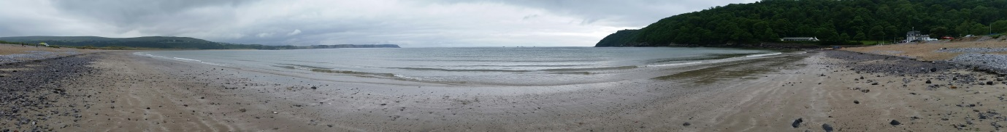
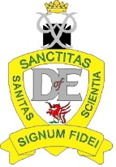
Duke of Edinburgh
Duke of Edinburgh
The Duke of Edinburgh's Award is an incredible experience and qualification, widely recognised by employers and education providers as the definitive qualification for demonstrating self-reliance, commitment and dedication. At St Illtyd’s we offer the Bronze and Silver award and each award is divided in to four sections:
1. A Skill Section – Young people must spend approximately one hour per week learning a new life skill (outside of school lessons). Popular choices include music, art, drama, cooking, DJing, committee skills, graffiti art, learning to drive and sign language. Unfortunately sports cannot count for this section, this is because sports come under the ‘physical recreation’ section.
2. A Volunteering Section – This section requires young people to spend approximately one hour per week doing voluntary work. This cannot be working for free for a commercial organisation like hairdressers, shop, café etc.
3. A Physical Recreation Section – This section requires young people to spend one hour per week of their own time engaging in physical recreation. It can be any form of activity and does not need to be in a team or competitive environment.
4. An Expedition Section – This section requires participants to undertake training to ensure they have the necessary skills and knowledge to complete a self- sufficient journey over a series of 2/3 days. This will require five supervised training days, culminating in a weekend walk without adult supervision, along an agreed route, carrying all the equipment and food needed for the duration of their expedition. Adult leaders monitor the progress of the groups by meeting them at check points along the route on these weekends.
Any two of sections 1 to 3 will need to be completed over a period of three months, with one section being completed over a period of six months. The Expedition section is completed over the course of eight months via the school. The award does require pupils to undertake a range of activities away from school and in their own time, which means that self-motivation and commitment are essential to anyone thinking of undertaking the award.
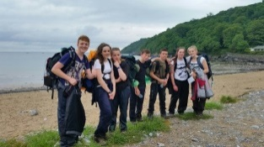
The award itself can be hard work, is also very rewarding, and ultimately participants will get out of the award what they put in to it. The cost of undertaking the award is £25. This includes a registration fee with the DofE and the cost of transportation to venues as part of the Expedition section. Successful participants at Bronze level will then be invited to undertake the award at Silver level in Year 11.

Make up and manicure

Make up and manicure
What is make up and manicure?
This course will give you the opportunity to explore both the practical and theoretical sides of make up and manicure. During the term you will learn various things such as planning a make up consultation, applying both day and evening make up, and then go on to develop further skills in manicures. Some sessions will be provided in terms of health and safety and the professionalisms of both these aspects of beauty.
The skills learnt on this course will not only give more confidence with both make up and manicures but will also boost your communication skills as you interact and learn together.

Crest Club
What is Crest Club?
CREST is a nationally recognised award scheme for project-based work which allows pupils to explore real-world Science, Technology, Engineering and Maths projects in an exciting way. It will give you the opportunity to investigate the Science behind a topic you are interested in by solving problems, thinking creatively and using many of the skills that you develop during your Science lessons.

Not only is the CREST award a perfect way to build lots of skills, it looks great on job, college and university applications and can even be used towards the skills section of a Duke of Edinburgh award. KS3 pupils can complete a Bronze award (about 10 hours of project work) and KS4 pupils can work towards a silver award (around 30 hours of project work) and all pupils will be supported by members of the Science department.

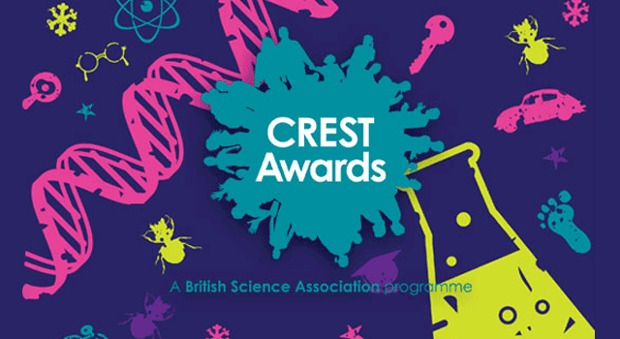

Life Skills
Life Skills
What is Life Skills?
This is a fantastic opportunity to learn new skills through ‘hands-on’ learning. Every opportunity will be taken to involve learners in activities that will help to develop their knowledge and understanding of essential life skills, such as team-building, confidence, community engagement, family relationships, safety and hygiene, health and nutrition, basic literacy and numeracy etc.
This is a bespoke course that will be moulded around the development and suggestions of the group. Attendees of the course will be encouraged to develop their skills through 'hands-on' activities and kinaesthetic learning techniques. The course will also make use of visual presentations and outside visitors, as well as visits into the community where possible. The main aims of the course are to encourage collaboration and team-work, learn new life skills and improve on literacy and numeracy skills. It may also lead onto additional qualifications, such as First Aid, and will be an impressive addition to include onto anyone’s CV!

Welsh for beginners

Welsh for beginners
What is Welsh for beginners?
Welsh For Beginners
Thousands of adults are now learning Welsh – but why? There are too many reasons to list them all, but here are some!
Over 600,000 people in Wales speak Welsh and there are over a million who understand it, not to mention those who live and speak Welsh outside Wales. And it’s growing… all children in schools in Wales either speak or learn Welsh so it is going to be a language of the future. All public sector organisations in Wales are legally bound to provide services in both Welsh and English and many private companies do so because it's good for business. This makes Welsh-speaking employees a very attractive asset to companies! Research also shows that employees with bilingual skills are more likely to earn a salary 8-10% higher than workers without bilingual skills.
But first and foremost, learning a new language is fun!
In the Welsh for Beginners class we will be learning the basics, talking about ourselves and others and using conversational language. The focus of the classes will be on oracy; in other words, speaking and listening to one another in Welsh.
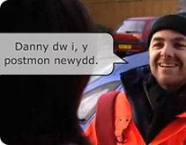

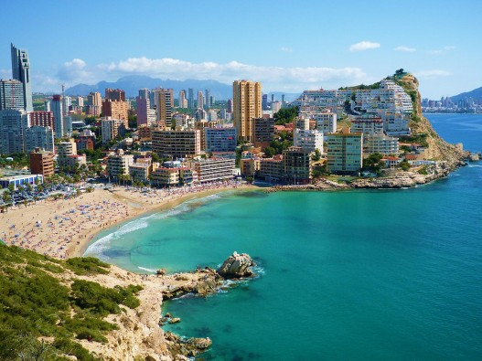

Holiday Spanish

Holiday Spanish
What is Holiday Spanish?
So you’re off to Spain soon? Why not join us and learn to speak Spanish for your holiday!
This course is designed for pupils, parents and the wider community. From ordering drinks at the bar and tapas at a restaurant, to knowing how to deal with situations such as going to the doctors, asking for directions and buying tickets, you will soon be equipped to speak to local Spaniards.

Spanish people immediately warm to anyone attempting to speak in their own language, which means you can make friends easily!
Without a doubt, holidays will become much more enjoyable and rewarding through taking this one hour per week course. ¡Hasta luego!
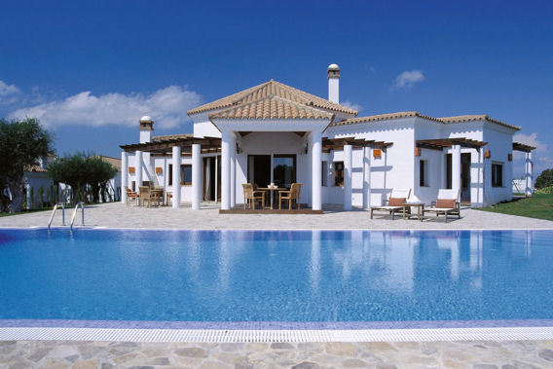
Period 6 – 2015

Staff | Course | Day | Time
Mr Harper | Geology GCSE | Monday | 2hrs
Mr Fleet | Psychology GCSE | Thursday | 2hrs
Mrs D.James | Sociology GCSE | Thursday | 2hrs
Mr Miles/Ms Pearson | Philosophy AS Level | Monday | 2hrs
Mrs Hobbs/Miss Evans | Geography GCSE | Monday | 2hrs
Mrs N.James/Miss Vella | Photography GCSE | Thursday | 2hrs
Mrs Hill | Welsh GCSE Top Up | Thursday | 2hrs
Mrs N.James | Jamie Oliver BTEC | Thursday | 2hrs
Mr Nelson/ Mr Walsh | Fishing/Angling | N/A | Variable
Mr Miles | Debating society | Thursday | 1hr
Mr Richards/Mr Harper | Duke of Edinburgh | N/A | Variable
Miss Chick | Make Up & Manicures | TBC | 1hr
Mrs G Lewis/Dr Rice | Science 'Crest Award' | Monday | 2hrs
Miss Williams/Mr Healey | Life Skills | Thursday | 2hrs
Mrs Hill | Welsh for adults/beginners | Monday | 2 hrs
Miss Bendle/Mrs Jenkins | Holiday Spanish | Monday | 1 hr

Course 1
Course 2

Name (Printed) :______________________________________________

Please circle: Pupil Parent Staff

Signed: ____________________________________________________

Date: ______________________________________________________

