 | ST. ILLTYD’S CATHOLIC HIGH SCHOOL  Newport Road, Rumney, Cardiff CF3 1XQ  Tel: 029 2077 8174 Fax: 029 2036 1641  E-mail: stilltydshigh@cardiff.gov.uk  Website: www.stilltyds.org.uk  Headteacher: Mrs. T. Jarvis

21st March 2017

Dear Parent/Carer

Re: Pupil’s leaving school during the school day

I would like to remind you that no pupil will be allowed to leave school during the school day without a parent or representative of the parent collecting them, this includes for illness, medical appointments or any other reason they may need to leave school during the school day.

I appreciate this can sometimes be difficult but we must put the safety of our pupils as a priority and would ask that you consider this when appointments are made.

Yours sincerely
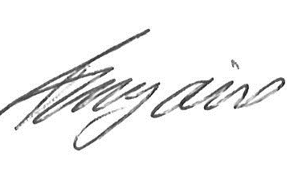
Mrs. T. Jarvis
Headteacher

