24th September 2020

Dear Parent/Carer

Due to the current COVID-19 restrictions we are unable to hold our annual Open Evening for parents and pupils in Year 6.

We would, therefore, like to invite you to visit us on our website www.stilltyds.org.uk. There you will find all the information you need about our school. From 19th October there will also be a virtual tour of the school available http://www.stilltyds.org.uk/virtual-tour/

Please look through the information pack and booklet. This should answer a lot of the questions you may have. It also includes the school’s admissions policy. Please read this carefully as this will help you to complete the application form for entry to the school.

The application form should be returned to us no later than 23rd November 2020. You will also need to include your supporting information with the completed application form. The supporting information is:
- A birth certificate or passport
- Proof of address and
- If your child is baptised Catholic a copy of their baptismal certificate

Please note if you are applying in category 8 you will need your place of worship to provide evidence.

Finally remember you must apply to us directly either by email, in person or by post as we are not part of the council’s admission process.

We look forward to receiving your application

Yours sincerely
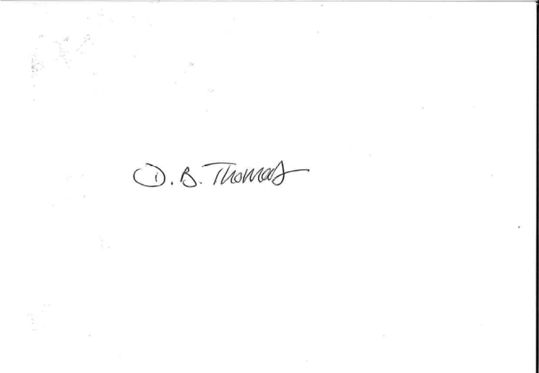
D B Thomas
Headteacher

